

**Faculty of engineering - Shoubra**

**Benha University**

**Research Project**

|  |  |
| --- | --- |
| **Department** | Electrical Engineering |
| **Division** | Computer Systems Engineering |
| **Academic Year** | 2019/2020 |
| **Course name** | Database Design |
| **Course code** | ECE323C |

**Title: -**

**Library management system**

By:

|  |  |  |  |
| --- | --- | --- | --- |
|  | Name | Edu mail | B.N |
| 1 | **Khaled Mahmoud** | **khaled160314@feng.bu.edu.eg** | **343022** |

**Approved by:**

|  |  |
| --- | --- |
| Examiners committee | Signature |
|  |  |
|  |  |
|  |  |
|  |  |
|  |  |

**Research objectives**

The long-time work could be automated not only in way could anyone understand but also in different ways not just one way I am going to illustrate library management systems which afford some advantage to the manager.

* What is data and what is database
* Database management systems and all its types
* Our example and how it achieved all life cycle of database development
* Schema and SQL code of how tables been built.

**Abstract**

This section is written at final stage. After you finish the whole research

It is an overview of your wholereport, and is between 70-100 words

**Table of contents**

Divide your research into sections or subjects, mention each section first page at this table

|  |  |
| --- | --- |
| **Subject / section** | **Page** |
| **Domain of project** |  |
| **EER Diagram** |  |
| **SQL implementation for tables** |  |

**List of Figures (If any)**

|  |  |  |
| --- | --- | --- |
| **Figure I.D** | **Description** | **Page** |
|  |  |  |
|  |  |  |
|  |  |  |
|  |  |  |
|  |  |  |
|  |  |  |

**List of Tables (If any)**

|  |  |  |
| --- | --- | --- |
| **Table I.D** | **Description** | **Page** |
|  |  |  |
|  |  |  |
|  |  |  |
|  |  |  |
|  |  |  |
|  |  |  |

**Introduction**

**Database is an efficient assortment of information. Databases bolster stockpiling and control of information. Databases make information the board simple. How about we examine not many models.**

**An online phone catalog would utilize database to store information relating to individuals, telephone numbers, other contact subtleties, and so forth.**

**Your power specialist organization is clearly utilizing a database to oversee charging , customer related issues, to deal with shortcoming information, and so on.**

**We should likewise consider the Facebook. It needs to store, control and present information identified with individuals, their companions, part exercises, messages, commercials and parcel more.**

**We can give endless number of guides to use of databases .**

**Database Design is an assortment of procedures that encourage the planning, advancement, execution and support of big business information the board frameworks. Appropriately planned database is anything but difficult to keep up, improves information consistency and are savvy as far as plate extra room. The database planner chooses how the information components connect and what information must be put away.**

**The principle destinations of database structuring are to deliver sensible and physical plans models of the proposed database framework.**

**The coherent model focuses on the information necessities and the information to be put away autonomous of physical contemplations. It doesn't fret about how the information will be put away or where it will be put away genuinely.**

**The physical information configuration model includes deciphering the coherent plan of the database onto physical media utilizing equipment assets and programming frameworks, for example, database the executive’s frameworks (DBMS).**

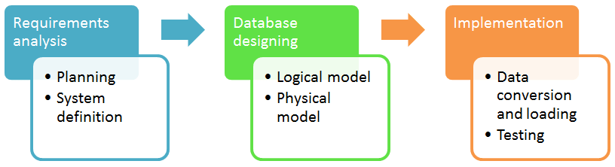Database Developer Life Cycle

Database Management System (DBMS) is a collection of programs which enables its users to access database, manipulate data, reporting / representation of  data .

Types of DBMS

Two types of Database techniques

1. normalization
2. ER Modeling

**Literature Review**

Domain :

Library project system to rental and buy books with payment methods and some info about customer and enable us to know if any book out of stock and display book with author and rate or price with language and categories.

Customer data

Will include some entities such as country, city, address, and customer. These entities will have related data to the customer who came to borrow or rent books.

Business

If inventory okay with renal book which want to be borrowed, now we have to include payment method and the staff of library so our entities will include staff, library, rental, payment. For rental we need customer data and inventory, so all attached with each other’s.

Inventory

Will include some entities such as book, category, language, author ( publisher ), inventory. These entities have book database each book have his own language and author but may be author have many books and so on.

ER-Molding :

out system is showed below with relation between entities and another section called view. It shows every prime keys for our entities and foreign keys like in customer entity the key prime is customer_id and have its own data type which is SMALLINT prime key is also foreign key to another entity like rental it have customer_id as foreign key with relation one to many.

For the entities relations many to many could not be support any sense in our life so we need to normalize and make more tables, like book and category we have third entity in-between called book_category have each prime as foreign to disassembly many to many relationships.

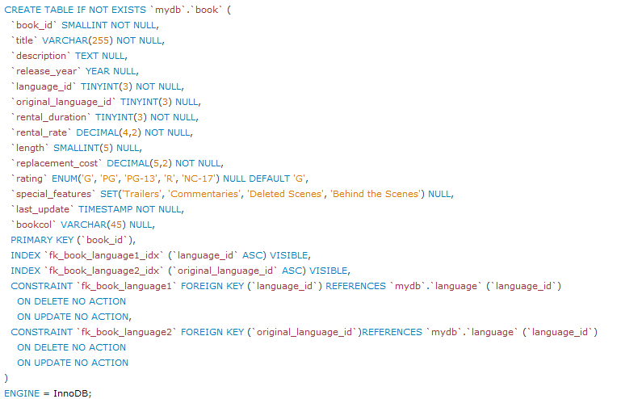SQL implementation for every table

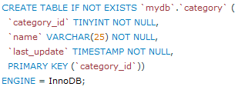

Figure implementation of category entity.

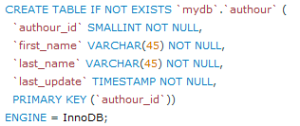

Figure author’s implementation

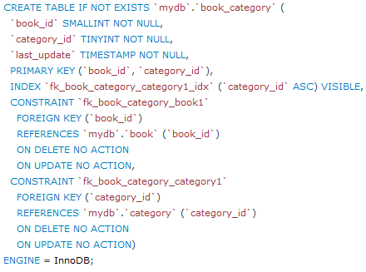

Figure implementation of book entity

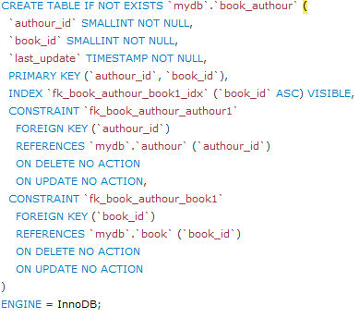

Figure book category implementation

Figure book_authour implementation

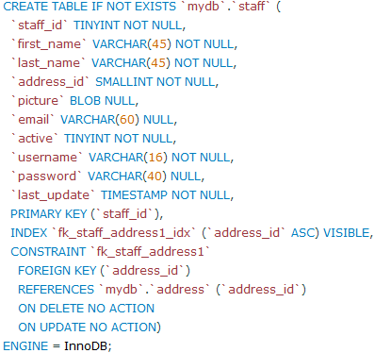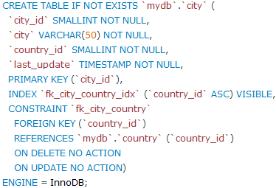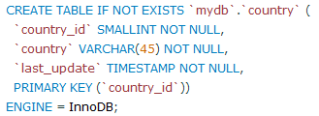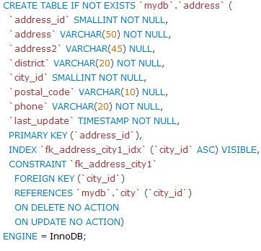

Figure 9 staff’s-entity implementation

Figure 8 city’-entity implementation

Figure country’s implementation

Figure address’s implementation

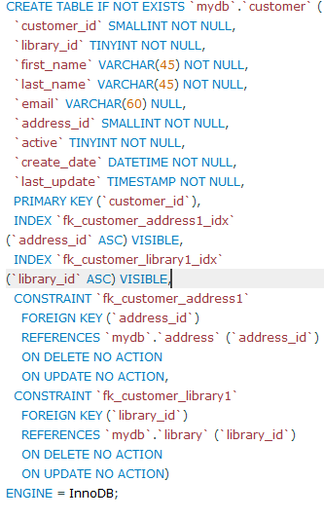

Figure 11 customer’s entity implementation

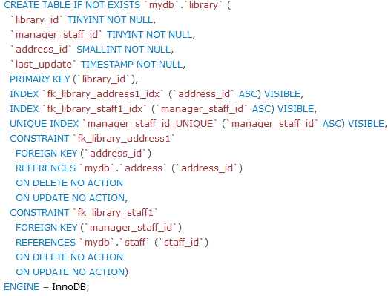

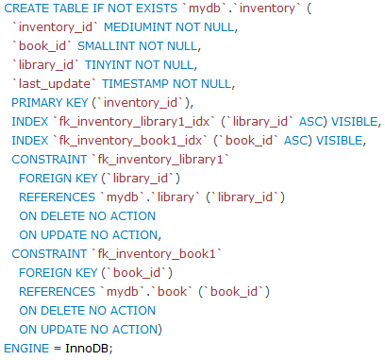

Figure 10 library’s entity implementation

Figure 12 inventory’s entity implementation

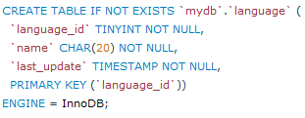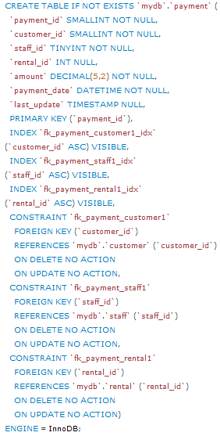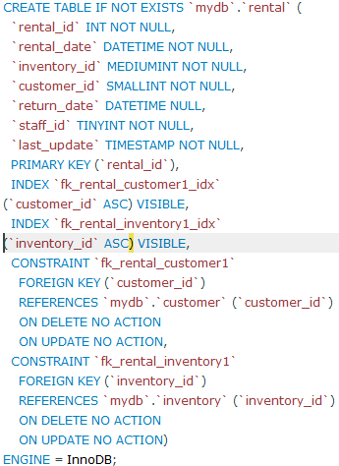

Figure 15 language implementation.

Figure 14 payment implementation

Figure 13 rental implementation

**Results and discussion**

Outlines what you found out in relation to your research questions or hypotheses, presented in figures and in written text.

Results contain the facts of your research. Often you will include a brief comment on the significance of key results, with the expectation that more generalized comments about results will be made in the Discussion section.

The Discussion section:

* comments on your results;
* explains what your results mean;
* interprets your results in a wider context; indicates which results were expected or unexpected;
* provides explanations for unexpected results.

Between 1 – 2 pages

**Conclusions**

Very important! This is where you emphasize that your research aims/objectives have been achieved.

You also emphasize the most significant results, note the limitations

Between 70 – 100 words

**References**

Includes a list of references that helped you in your research

**It is strongly advised to use the available research sources on the Egyptian Knowledge Bank, EKB**.

**Layout and formatting**

**(Guide, don’t include this page in your research)**

Use this template

**Paper:** A4

**Margins:** 2.5 cm all from top and bottom

**1.**9 cm from left and right

**Line spacing:** 1.5

**Font:** Time New Roman

**Font size:** 14 (Except headings)

**No of pages:**Between 5 and 10 pages (Not including cover)